EXPERIEMENT:16: . Create a Simple Web Application using Java or Python and host it in any Public Cloud Service Provider (Azure/GCP/AWS) to demonstrate Platform as a Service (PaaS).

STEP:1:GO TO THE APP SERVICES CREATE A STATIC WEB APP AND FILL THE BASCIS.

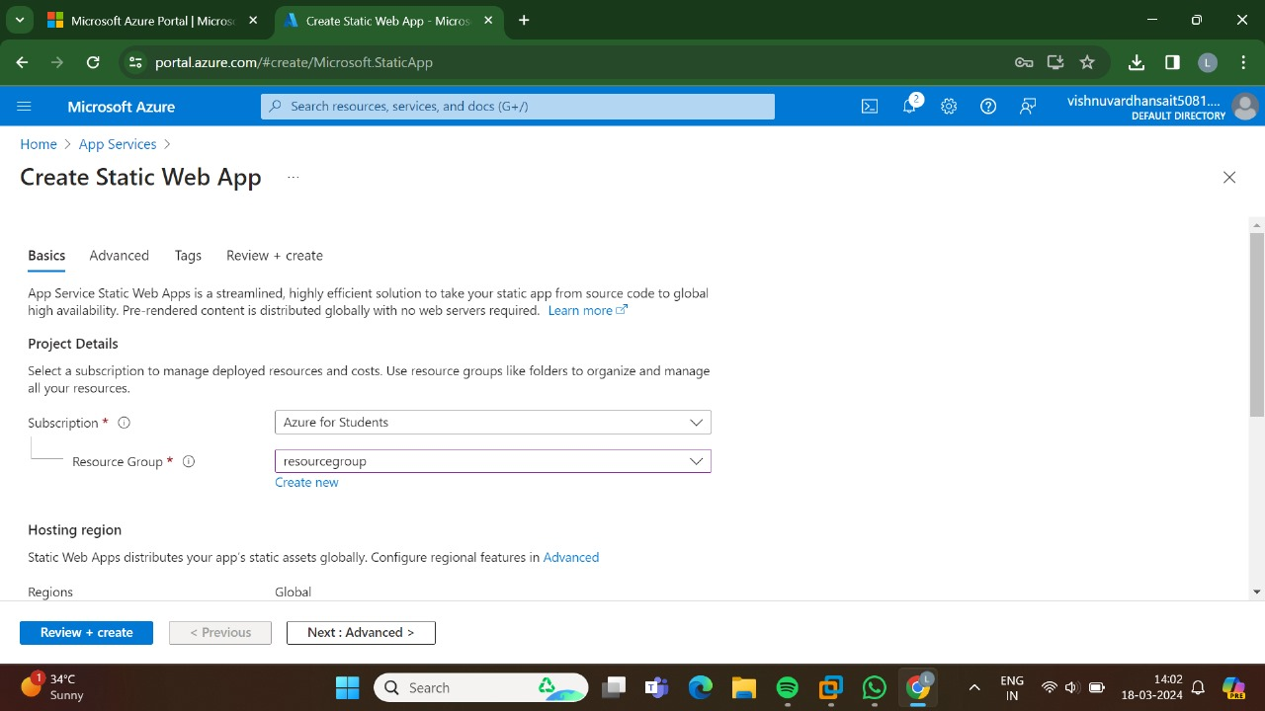

STEP:2: AND,THEN GO FOR THE ADVANCED.

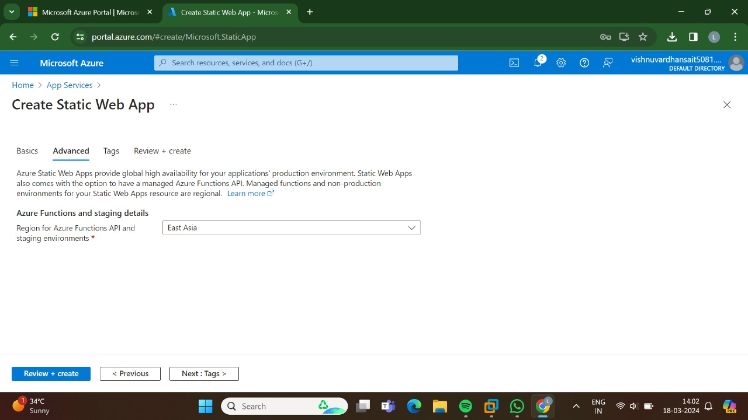

STEP:3:AND,THEN GO FOR THE TAGS.

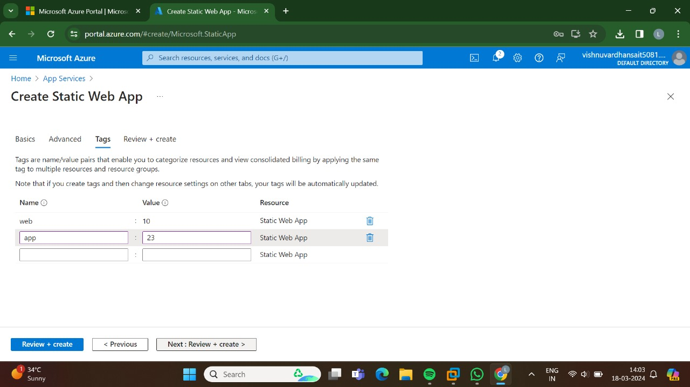

STEP:4:AND,THEN GO FOR THE REVIEW +CREATE AND THEN CLICK CREATE.

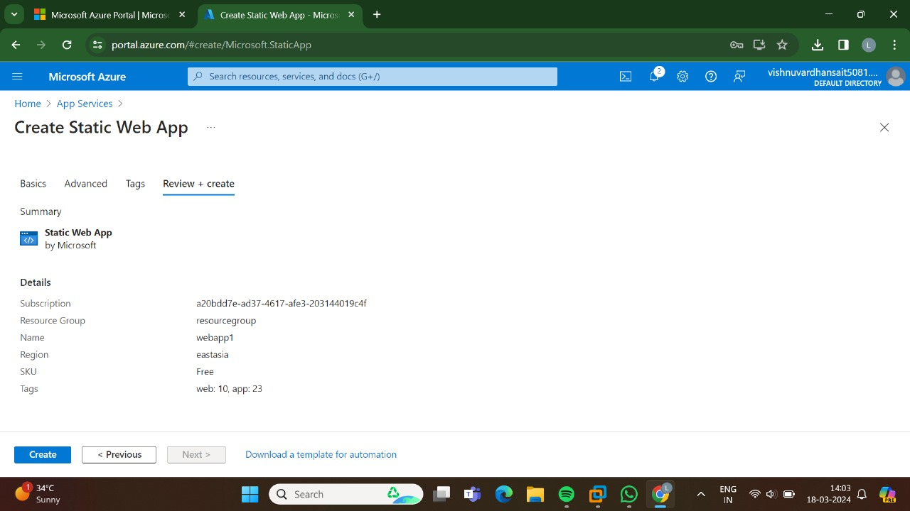

STEP;5:NOW,THE DEPLOYMENT IS INPROGRESS.

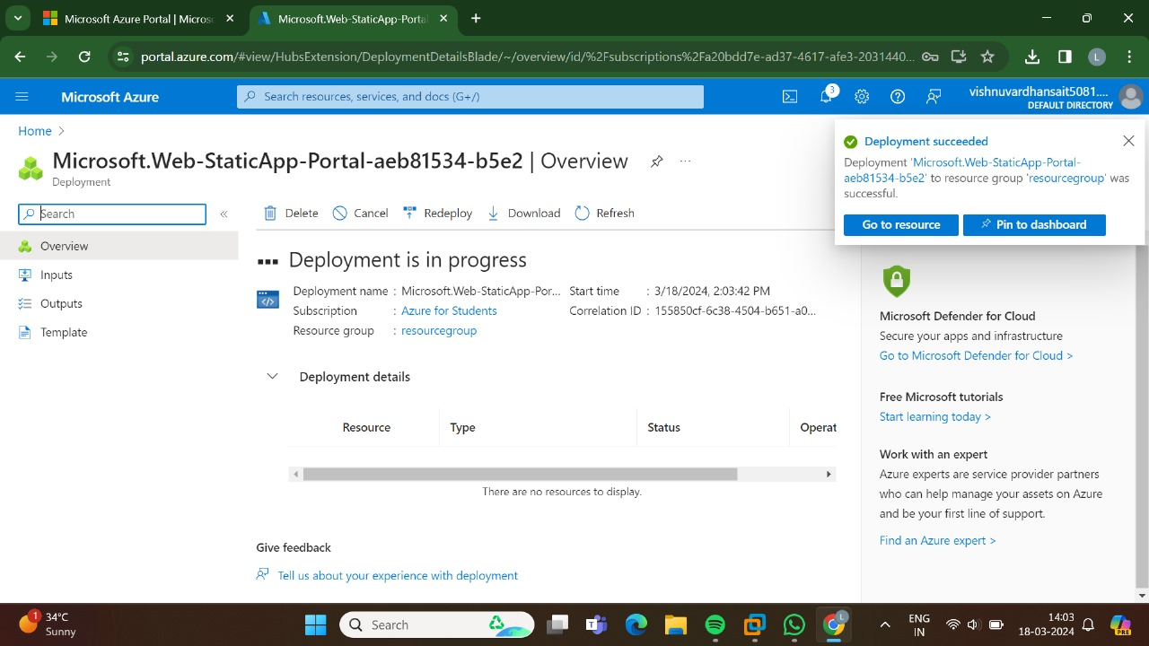

STEP:6::THE DEPLOYMENT HAS BEEN DONE SUCCESSFULLY.

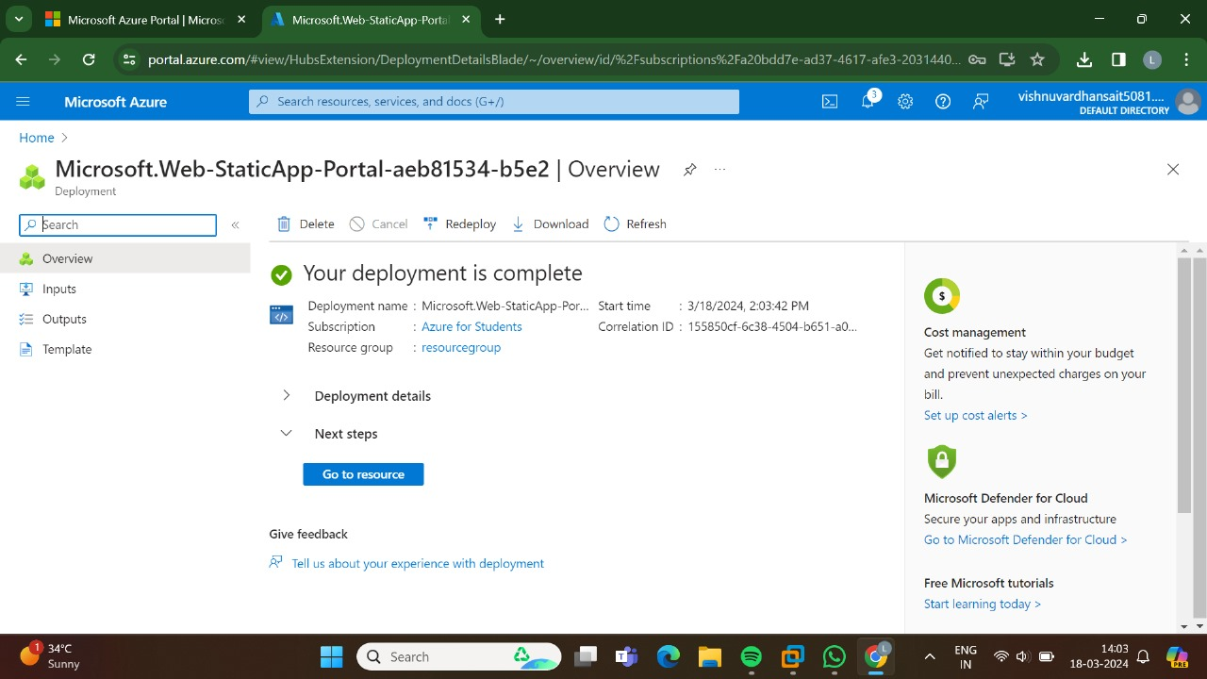

STEP:7:AND,NOW GO TO THE URL.

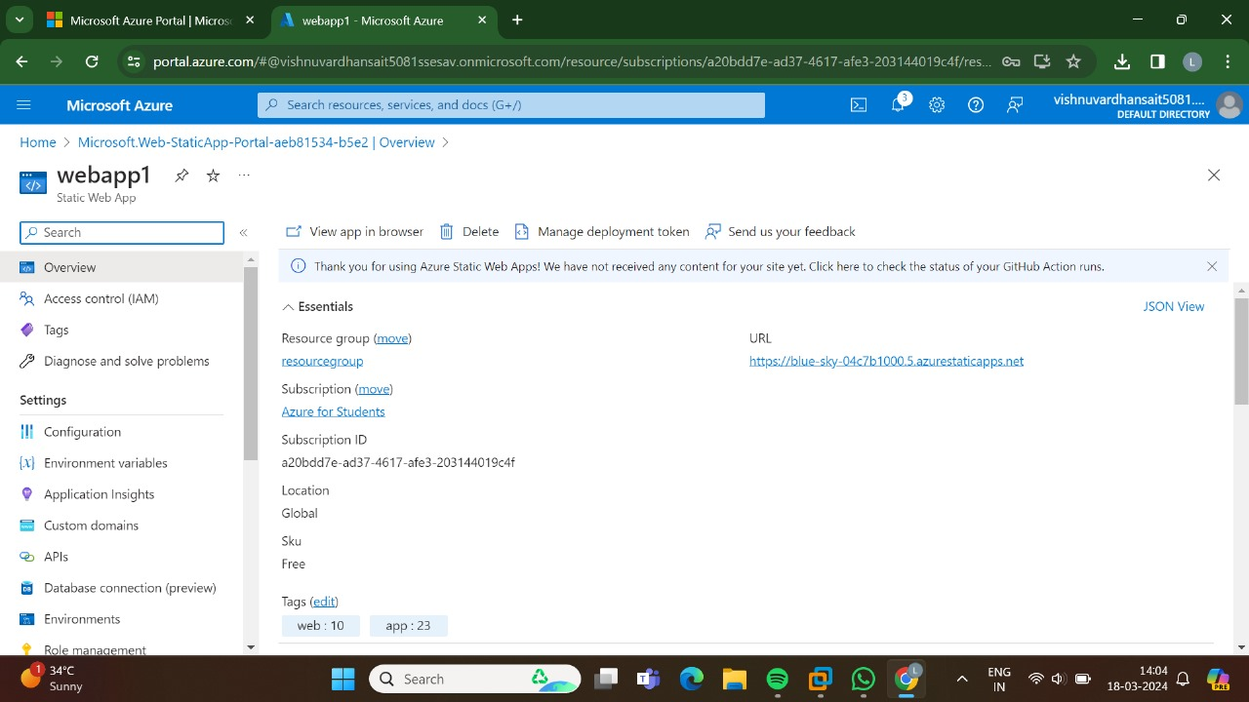

STEP:8:: THUS, THE NEW WEB APP HAS BEEN CREATED SUCCESSFULLY.

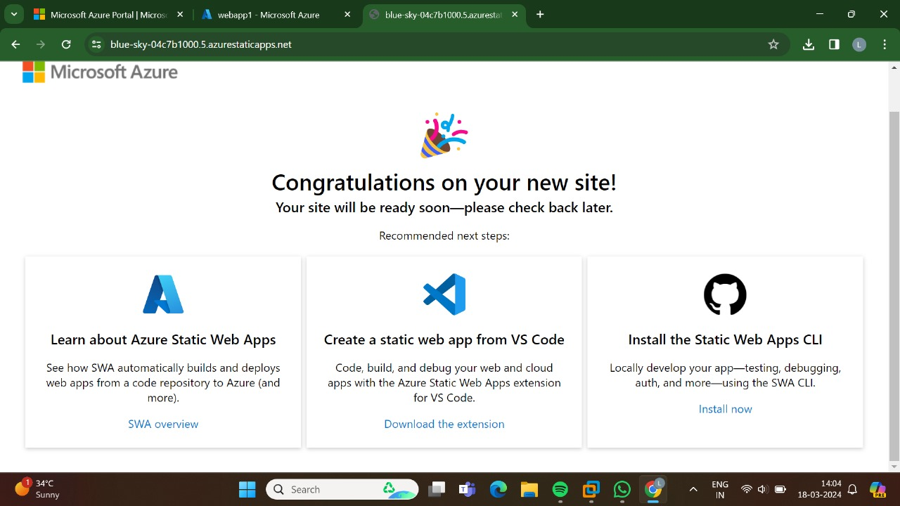

RESULT: THUS,THE PROGRAM FOR THE WEB APPLICATION HAS BEEN EXCEUTED SUCCESSFULLY.